OOP LAB

Tamojit Das ; Sec: A ; Roll: 7; Grp: C1

Assignment 2

Question 1:

import java.util.Scanner;

class P1

{

public static void main(String[] args) {

Scanner sc=new Scanner(System.in);

System.out.print("Enter x y: ");

int x=sc.nextInt();

int y=sc.nextInt();

if (x>0){

if (y>0){

System.out.println("quadrant 1");

} else {

System.out.println("quadrant 4");

}

} else {

if (y>0){

System.out.println("quadrant 2");

} else {

System.out.println("quadrant 3");

}

}

}

}

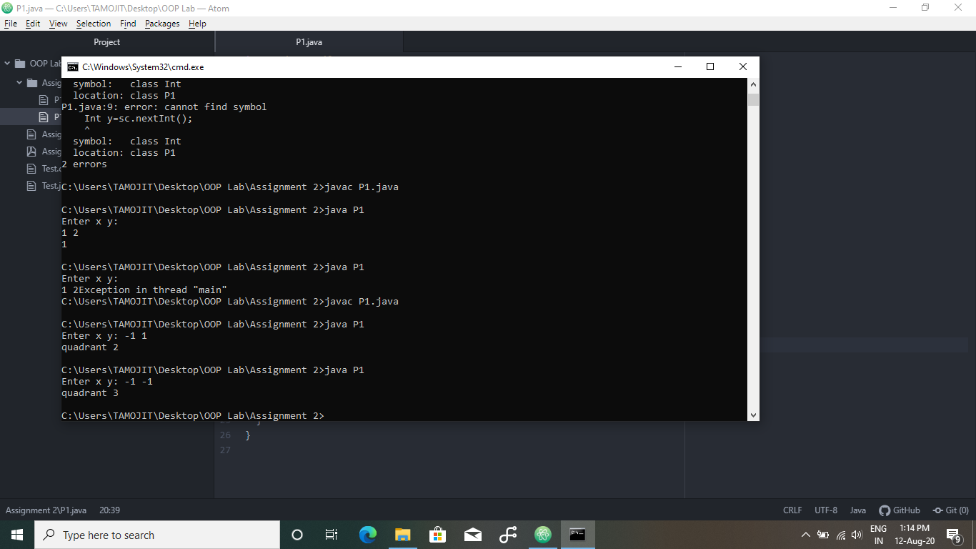

Question 2:

import java.util.Scanner;

class P2{

public static void main(String[] args) {

Scanner sc=new Scanner(System.in);

System.out.print("Enter: ");

char x=sc.next().charAt(0);

switch(x){

case 'a':

case 'A':

System.out.println("Action movie fan");

break;

case 'c':

case 'C':

System.out.println("Comedy movie fan");

break;

case 'd':

case 'D':

System.out.println("Drama movie fan");

break;

default:

System.out.println("Invalid choice");

}

}

}

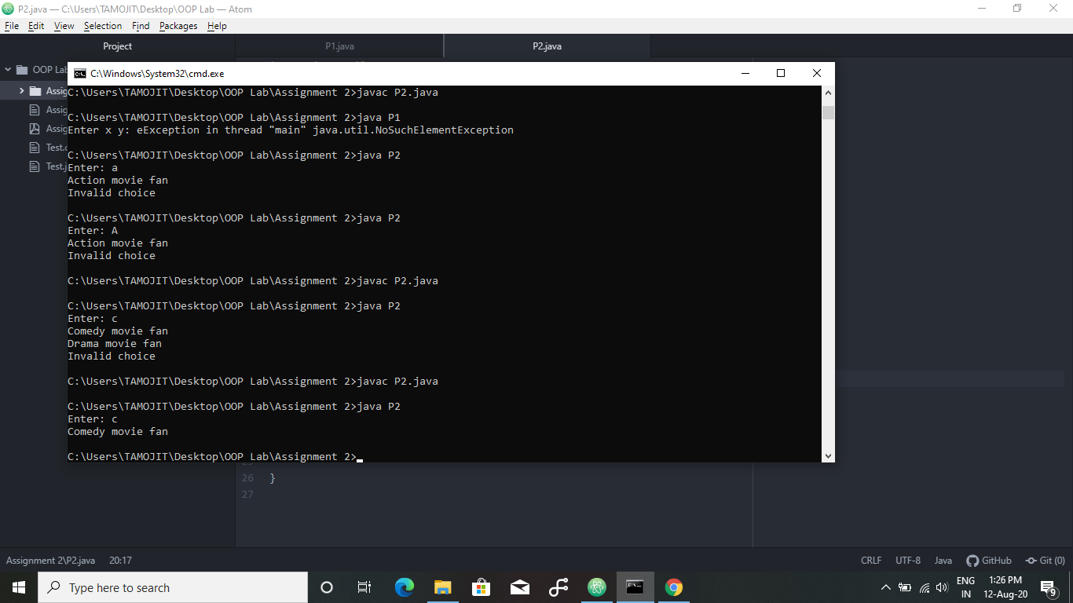

Question 3:

import java.util.Scanner;

class P3{

public static void main(String[] args) {

Scanner sc=new Scanner(System.in);

System.out.print("Enter Salary Merit");

int salary=sc.nextInt();

int merit=sc.nextInt();

if (salary>500 && salary<600){

System.out.println("Grade C");

}

else if (salary>600 && salary<649 && merit<10){

System.out.println("Grade C");

}

else if (salary>600 && salary<649 && merit>10){

System.out.println("Grade B");

}

else if (salary>649 && salary<700){

System.out.println("Grade B");

}

else if (salary>700 && salary<799 && merit<20){

System.out.println("Grade B");

}

else if (salary>700 && salary<799 && merit>20){

System.out.println("Grade A");

}

else if (salary>799){

System.out.println("Grade A");

}

}

}

